TeMA | Journal of  Land Use, Mobility and Environment

TeMA Elderly Mobility  SPECIAL ISSUE X.2018 | XX-XX (by Editor)  print ISSN 1970-9889, e- ISSN 1970-9870  http://dx.doi.org/10.6092/1970-9870/xxxx (by Editor)  Licensed under the Creative Commons Attribution  Non Commercial License 3.0  www.tema.unina.it | 
How to cite item in APA format:
Surname, N. (Year). Paper Title. Tema. Journal of Land Use, Mobility and Environment, xx-xx.
doi: http://dx.doi.org/10.6092/1970-9870/xxxx (by Editor)

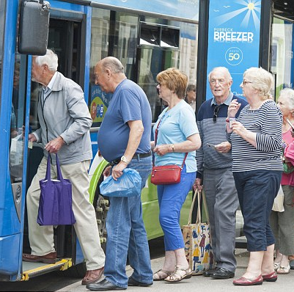  Insert Picture 8 cm x 8 cm  300 dpi | Is Milan a CIty for elderly? (style: PAPER TITLE)  Mobility for aging in place (style: SUBTITLE)
ABSTRACT (style: ABSTRACT – max 240 words)
Italy is among the ‘eldest’ countries in the world, with increasing numbers of elderly becoming older and participating in society. In order to ensure that these and future elderly are able to age in place, the possibilities to get around in one’s own neighborhood should be available and safe in use. In order to gain insight in the mobility issues of elderly in Italy we investigated 11 Milanese neighborhoods through in depth interviews to see how elderly perceive their neighborhood in terms of mobility. We find that that the respondent move at least twice a day outside and have a preference for LTP and walking, followed by the use of the private car. Most of them prefer to age in place and feel happy in their current environment. However, more research needs to be done to give proper policy handles for local municipalities before we can agree what is necessary for age friendly neighborhoods. The paper is organized into five sections. The Introduction is followed by a background section. Section three is dedicated to the description of the elderly in the city of Milan: how many they are, and in which neighborhood they are concentrated. The survey and the descriptive statistics are described in section 4.Conclusions and policy implications follow.

KEYWORDS:
Elderly, Mobility, Neighborhood, Milan, Local Public Transport

1 introduction
One of most pressing challenges related to contemporary urban living is certainly the progressive ageing of population at the global level, and particularly in high-income countries (van Hoven et al., 2012). The ageing of the population causes structural problems for i.g. the finance of care or ageing in place. The current generation of people turning old is healthier, more highly educated and more active than any previous generation. The profile of elders, their background and preferences play a key role in shaping their decisions in terms of mobility. As consumers, older people have much higher spending capabilities (Dobbs et al., 2016); as travelers, they have grown up experiencing the great expansion of individual means of transportation such as cars (Siren et Haustein, 2016). Awareness of this is fundamental when planning interventions aimed specifically at improving mobility among elders. Modern cities need to adapt to the emerging needs of elderly people (Buffel and Philipson, 2012), and for achieving this goal we need to understand their daily patterns in mobility.

One of the main aspect improving the quality of life of elderly is mobility, which encompasses different dimensions of urban life that include housing (de Jong and Brouwer, 2012), transportation, work-related activities and social interactions. Mostly it is related to decisions about moving from one place to another with the help of transport network and services (Beimborn et al., 1998) and as such important for everyday activities, from grocery shopping to reaching the workplace. For elderly it also adds a healthy lifestyle by providing opportunities for physical activity and movement (McPhee et al.,2016).

Within this context, this paper gives insights in the demand of mobility among elderly (65+) living in the municipality of Milan, which is the Italian large city that has implemented sustainable mobility (see Comune di Milano, 2015 for the Urban Plan for Sustainable Mobility- PUMS), and it has been awarded in 2016 by the European Union with the 2016 Access City Award, as the most accessible-friendly city, particularly for people with disabilities. Specifically, we compare mobility patterns across age groups and gender, including the level of use of public transportation among elders.
To reach the aim of the paper, the results of a survey addressed to elderly living in the city of Milan in the year 2017 are presented. People have been interviewed in 11 neighborhoods characterized by a high concentration of elderly. It results that the respondent move at least twice a day outside and have a preference for LTP and walking, followed by the use of the private car. Most of them prefer to age in place and feel happy in their current environment.
The paper is structured into 4 sections. The Introduction is followed by a background section.. Section 3 is dedicated to the description of the elderly in the city of Milan: how many they are, in which neighborhood they are concentrated. The survey and the descriptive statistics are described in section 4.Conclusions and policy implications follow.

2 BACKGROUND

Mobility is central in assessing the quality of life in modern cities (Pucci and Colleoni, 2016) since it encompasses many dimensions, from the psychological aspects of travelling to the benefits of physical activity and the ability to maintain a social network (Alsnih and Hensher, 2003). Mobility is determined by the spatial distribution of activities and services and the transport infrastructure. Directly linked to mobility, is the concept of accessibility, which has been defined as the ‘ease with which any land-use activity can be reached from a location using a particular transport system’ (Dalvi and Martin, 1976). Mobility and accessibility are fundamental for carrying out everyday activities; mobility promotes healthy ageing by providing opportunities for physical activity and movement (McPhee et al., 2016). For this reason, the organization of space and services that cities can offer becomes critical for the participation of elderly to public life and their well-being.
The current generation of (pre) elderly are Baby-boomers (born in the period after the second world war). They have benefited from many technological improvements and much more conversant with the use of technological devices. In terms of transportation, the baby boomers are the first generation who has fully experienced modern mobility, with a regular use of private automobile, and have a high preference for driving their own car (Burlando and Cusano, 2014) . This attachment to the private car make them use little public transport. Furthermore, research indicated that many feature of public transport services are still far from being user-friendly for older users in Europe (Ryan et al, 2015). From the average time allowed for boarding and validating the ticket to the comfort of seats and benches, there are still too many elements that make the experience of riding a bus or a tram almost ‘hostile’ to older people (Metz, 2003). This despite the fact that any improvement to public transport, even if only targeted towards older users, would benefit everyone.
In many cities people over 65 years benefit from discounted fares. This policy, quite widespread, responds to the logic of facilitating the transportation of people whose travel options are conventionally considered very limited. This is less true, the new generation of elderly is healthier than ever before and has a stronger preference for cars, compared to all the other means of transportation.
When analyzing walking behaviors of elderly in relation to overall mobility, when people live in a pedestrian-friendly environment, walking can represent a valid alternative. Among elderly, walkability is associated with increased physical activity (King et al., 2011), lower bodyweight (Frank et al., 2010) lower levels of depression (Berke et al., 2007) and higher levels of social capital (Leyden et al., 2003). Urban spaces are in general full of barriers like steps too steep or doors tough to open. It is difficult for elderly people to navigate the complexity that modern cities have reached.

While few studies on elderly mobility have been carried out in Europe and worldwide (see Burlando and Cusano, 2014), little is known about the Italian context, although Italy is one of the oldest country, with about ¼ of the residents aged between 60 and 80 (ISFORT, 2016). To our knowledge, the only studies concerning the mobility attitude of Italian elderly have been developed by ISFORT (Istituto Superiore di Formazione e Ricerca per i Trasporti) with its annual report AUDIMOB (Osservatorio su stili e comportamenti di mobilità degli Italiani). Specifically, AUDIMOB developed a study on elderly mobility in Italy in 2015 by age classes (60-69 and 70-80 years) and travel behavior (why they move and how often, which transport modes they choose, number of trips daily, distance walked daily, etc.) (ISFORT, 2016). This study has shown a decreased mobility by elderly over the total population, but compared to the year 2001, the traffic volume generated by elderly has increased. Besides, the use of the private car among elderly has increased since 2007 (about +8% for the elderly 60-69, and +10% for those aged more 70-80), with a reduction of the use of Local Public Transport (LPT), bike and foot. Furthermore, they found that the willingness to change the modal choice is larger for people aged 60-69 (31.7% is willing to reduce the use of car, and 34.2% is willing to use the LPT), than for those aged 70-80 (19.3% is willing to reduce the car use and 1 out of 4 would prefer LPT). The present paper aims to fill the gap in the literature by focusing on the Milan case.

3 elderly in milan: who and where
The distribution of elderly in Italy seems to follow a geographical patterns: northern and central regions are those with the highest percentage of old people over the total population (Figure 1). Between the ‘youngest’ region (Campania, 17.6%), and the ‘oldest’ (Liguria, 28%) there is a difference of more than 10 percentage points.

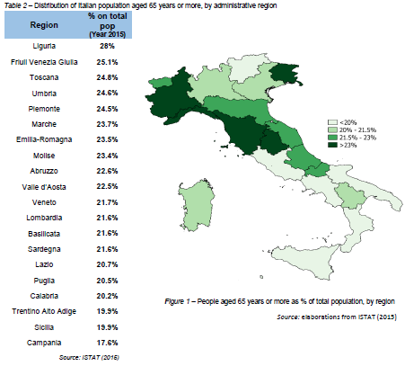
Fig. 1 People aged 65+ and % of total population by region
Source: ISTAT (2016)

Based on the data from the National Institute of Statistics (ISTAT) in 2015 the population of elderly – considered as people aged 65 years or more – in Milan amounts to a total of 316,434 individuals (Table 1), which represent 21.6% of the total national population (Figure 1).

Age group | Male | Female | Total
65 – 69 yrs. | 33,158 | 41,988 | 75,146
70 – 74 yrs. | 28,646 | 38,032 | 66,678
75 yrs. or more | 64,554 | 110,056 | 174,610
Total | 64,554 | 110,056 | 316,434

Tab. 1 Population of elderly residents in Milan (by age group and sex)
Source: ISTAT (2015)

Looking at a smaller scale, the municipality of Milan is composed by 88 macro-neighborhoods (NIL- Nuclei d’identità locale, “Local identity nuclei”), which are characterized by a different concentration of elderly (Figure 2). When calculating the Location Quotient of elderly at the level of NIL, 11 NIL show a value higher than 1, meaning that they show a concentration of elderly larger than the average in Milan.

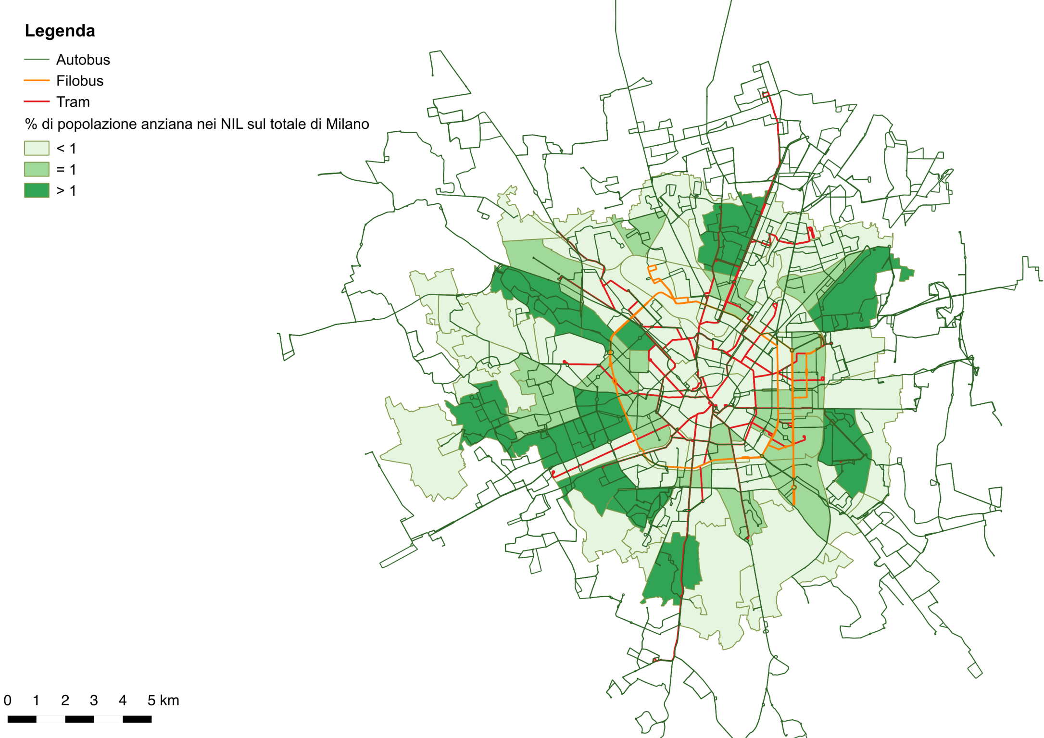
Fig. 2 Macro-Neighborhoods of Milan (NIL)- Location Quotient about elderly Source: Authors’ elaboration

Note: Location Quotient (LQ) = ((ElderlyNIL/ PopulationNIL)/(Elderly Milan/ PopulationMilan))*100. The 11 Nil are: Lambrate, Parco Lambro-Cimiano, Affori, Niguarda-Ca’ Granda, Baggio, Gallaratese, Quarto Oggiaro, Lodi-Corvetto, Barona, Gratosoglio-Ticinello, Mecenate.

4 ELDERLY MOBILITY IN MILAN: RESULTS FROM THE SURVEY
In the period May-June 2017, face-to-face interviews to elderly living in the 11 neighborhoods, presented in the previous section, have been carried out. First a focus group with 30 elderly has been developed to the test the questionnaire, then 149 people have been contacted, and 129 have completed the interview. Potential participants have been approached during their everyday activities in different public and private spaces (recreational places – i.e. park, cultural associations –, services – i.e. supermarket, post office –, bus stops, and underground stops), at different days, and different times. The questionnaire was composed of 5 main sections: (i) socio-demographic background; (ii) education, economic background and use of means of communication; (iii) health status; (iv) social interactions and housing and surrounding environment; (v) mobility habits. The face to face interviews have been carried out using the KoBoToolbox app for the smartphone.
The average age of the 129 interviews is 76 years, and specifically, 47.3% are young elderly (65-75), and 52.7% are old elderly (+76); besides, they are female for 42.6% and male for 57.4%. About 94% are retired, and 17% achieved a university degree, 40.3% high school, 28.7% secondary school and 13.2% primary school.

- Use of internet  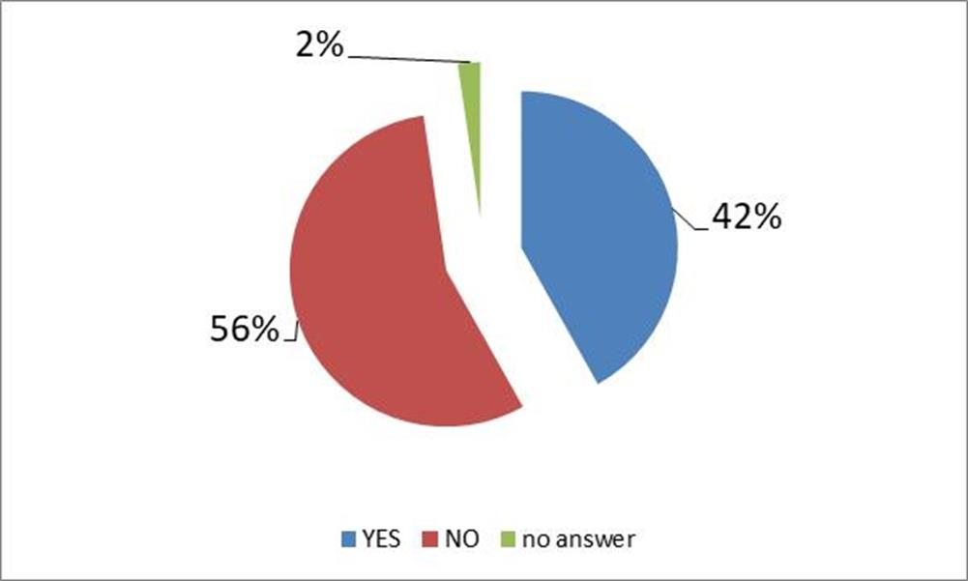 | - Interaction with families/ friends  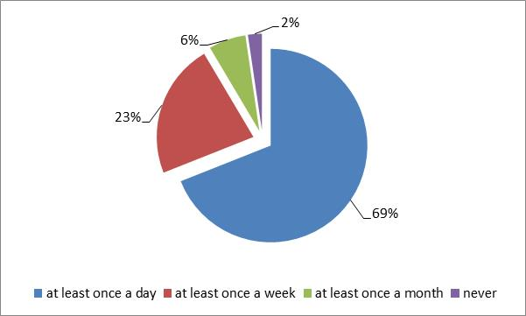
- Place in ageing  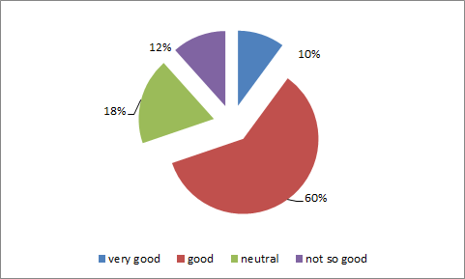 | d) Ageing in place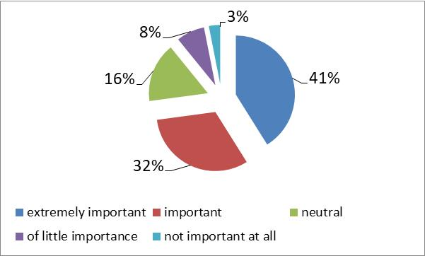
Fig. 3 (a, b, c, d) Respondents’ answers
Source: Authors elaboration

On average, they declared a good health status, about 84% are satisfied with their life in general and 42% of them use internet (Figure 3a). As concerns social interactions, the respondents tend to be rather active with 69% interacting at least once a day (Figure 3b). The majority rated positively the neighborhood where she/he lives in terms of quality of life (place in ageing: 70%), and stated to prefer to ageing in place ( 41% extremely important, 32% important) (Figure 3c).
The analysis of elderly mobility underlines that 24% makes 2 moves per day, 30% 4 moves, 25% 6 moves and 21% 8 and more moves. They show a preference for walking (93%), mainly for daily duties, visit friends and relatives living nearby, using LPT (81%), private car (60%) and finally bike (29%). Among the LPT they declared to prefer buses than the underground because the stops are closer to each other. The bike is preferred by men, which are less concerned than women about the lack of bike lanes in the neighborhood.

- Average n. of moves by day  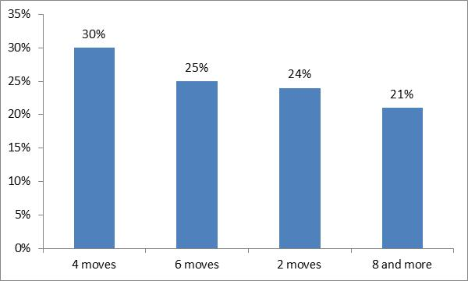 | - Use of transport modes (%)  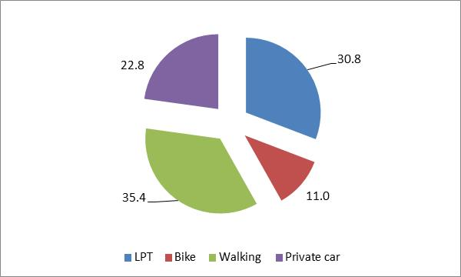
Fig. 4(a, b) Elderly mobility
Source: Authors elaboration
The analysis of elderly mobility underlines that 24% makes 2 moves per day, 30% 4 moves, 25% 6 moves and 21% 8 and more moves. They show a preference for walking (35.4%), mainly for daily duties, visit friends and relatives living nearby, using LPT (30.8%), private car (22.8%) and finally bike (11%). Among the LPT they declared to prefer buses than the underground because the stops are closer to each other. The bike is preferred by men, which are less concerned than women about the lack of bike lanes in the neighborhood.

5 CONCLUSIONS AND POLICY IMPLICATIONS
Summarizing, it results that the respondent move at least twice a day outside and have a preference for LTP and walking, followed by the use of the private car. Most of them prefer to age in place and feel happy in their current environment. Of course, these respondents are the elderly that are vital and still able to get around by themselves, this is a bias in the respondents – due to our selection method - that we are aware of. Banister and Bowling (2004) state that mobility and social networks are important for elderly and their perceived quality of live, but also agree that the range of activity involvement is very varied. Of course, we do not know how the people that we not interviewed feel about the transport possibilities in their neighbourhood and whether they have obstacles in using LTP, walking or other.
Even though the selection bias exist, we can say that as long as health allows, Milanese elderly are using LPT and walking as major travel modes, and even though they like the use of the private car, it is not the travel mode that is used most. McPhee et al. (2016) link especially physical activity in movement as a tool to promote healthy ageing. Combined with the fact that most of the respondents are willing to age in the same neighbourhood, this is a sign that Milanese elderly can age in place. Also the fact that quite a large group of the respondents still use the bike – even though more men than women – allows us to say that Milanese neighbourhoods are sufficient to age in, in terms of mobility, for those that are healthy enough to go out. Interesting, women are more satisfied with their local environment than men. Law (1999) points out that there is a gender bias in how men and women experience their daily mobility and this might be reflected in how content they are about their daily environment.
Even though the first results indicate that ageing in place is possible in Milanese neighbourhoods, we are aware that we have no information about the perception and use of transport from those elderly we did not interview because they tend to stay mainly at home. In order to give policy suggestions we should find out why the people that stay at home and therefore not use LPT, or do their own shopping on foot are not going out. Are they restricted by health reasons, or do they feel unsafe or do they find it hard to use LPT?. This could be health issues, or are there physical limitations and obstacles in the daily mobility environment, that could be overcome by different planning or regulations? Urban design can contribute to the walkability of the neighbourhood. To create a truly age friendly environment urban design needs to meet to the mobility need of all elderly, even those that are now home bound (Rosenbloom, 2009).

acknowledgements
This work has been supported by Fondazione Cariplo (Grant n° 2017-0942). The authors thank the participants at the ERSA 2017 conference in Groningen (NL), and at the SIET 2018 conference in Milan (IT). Also gratefully acknowledged is the help with the data gathering by Marcello Gerlomini.

REFERENCES (style: REFERENCE TITLE)
Alsnih, R., & Hensher, D. A. (2003). The mobility and accessibility expectations of seniors in an aging population. Transportation Research Part A: Policy and Practice, 37(10), 903-916.
Banister, D. & A. Bowling (2004) Quality of life; the transport dimension. Transport Policy 11(2), 105-115
Beimborn, E., Horowitz, A., Vijayan, S., & Bordewin, M. (1999). An Overview: Land Use and Economic Development in Statewide Transportation Planning.
Berg, J., Levin, L., Abramsson, M., & Hagberg, J. E. (2015). “I want complete freedom”: car use and everyday mobility among the newly retired. European Transport Research Review, 7(4), 1-10.
Berke, E. M., Koepsell, T. D., Moudon, A. V., Hoskins, R. E., & Larson, E. B. (2007). Association of the built environment with physical activity and obesity in older persons. American journal of public health, 97(3), 486-492.
Buffel, T., & Phillipson, C. (2012). Ageing in urban environments: Developing ‘age-friendly’cities. Critical Social Policy, 32(4), 597-617.
Burlando, C., and Cusano, M.I. (2014) Consequences of demographic changes on urban mobility: an overview of ageing in modern societies. Collana Percorsi di Scienze Economiche e Sociali, vol.11, Dicembre.
Comune di Milano (2015), PUMS, Piano Urbano Mobilità Sostenibile, Settore Pianificazione Programmazione e Mobilità, Milan.
Dalvi, M. Q., & Martin, K. M. (1976). The measurement of accessibility: some preliminary results. Transportation, 5(1), 17-42.
Dobbs, R., Manyika, J., Woetzel, J., Remes, J., Perry, J., Kelly, G., Pattabiraman, K. & Sharman, H. (2016) Urban World: the older consumers to watch, McKinsey Global Institute.
Frank, L., Kerr, J., Rosenberg, D., & King, A. (2010). Healthy aging and where you live: community design relationships with physical activity and body weight in older Americans. Journal of physical activity & health, 7(1), S82.
ISFORT (2016), Si cambia mezzo. Over 60 meno sostenibili, Fermata n.26, Audimob, ISFORT, Rome (www.isfort.it)
ISTAT (2015) Popolazione e famiglie [Accessed 18 April] Available from URL: http://www.istat.it/it/anziani/popolazione-e-famiglie.
King, A. C., Sallis, J. F., Frank, L. D., Saelens, B. E., Cain, K., Conway, T. L., ... & Kerr, J. (2011). Aging in neighborhoods differing in walkability and income: associations with physical activity and obesity in older adults. Social Science & Medicine, 73(10), 1525-1533.
Leyden, K. M. (2003). Social capital and the built environment: the importance of walkable neighborhoods. American journal of public health, 93(9), 1546-1551.
Law, R. (1999) Beyond women and transport: towards new geographies of gender and daily movement and daily mobility. Progress in Human Geography 23(4): 567-588
McPhee, J. S., French, D. P., Jackson, D., Nazroo, J., Pendleton, N., & Degens, H. (2016). Physical activity in older age: perspectives for healthy ageing and frailty. Biogerontology, 1-14.
Metz, D. (2003) Transport policy for an ageing population, Transport Reviews, 23:4, 375-386
Pucci, P., & Colleoni, M. (Eds.). (2016). Understanding Mobilities for Designing Contemporary Cities. Springer International Publishing: Imprint: Springer.
Rosenbloom, S. (2009). Meeting transportation needs in an aging-friendly community. Generations – Journal of the American Society on Ageing, 33(2), 33-43.
Ryan, J., A. Wretstrand & S.M. Schmidt (2015) Exploring public transport as an element of older persons' mobility: A Capability Approach perspective. Journal of Transport geography 48: 105-114.
Siren, A., & Haustein, S. (2016). How do baby boomers' mobility patterns change with retirement?. Ageing and Society, 36(05), 988-1007.
Van Hoven, B., Brouwer, A., Meijering, L., & McCann, P. (2012). Demographic Change, Ageing and Societal Challenges in Europe. European Spatial Research and Policy, 19(1), 5.
AUTHOR’S PROFILE

